Computer Seekho
Business Requirement Document

V 1.3

PREPARED BY | Jayant Ponkshe
DATE | 10-Oct-25

Document Control:

VERSION | AUTHOR | DATE | CHANGE DESCRIPTION | APPROVER & DATE
0.01D | Jayant Ponkshe | 18-Mar-18 | Initial Draft
1.0 | Jayant Ponkshe | 20-May-18 | Baseline
1.1 | Jayant Ponkshe | 13-Oct-22 | Detailing of Admin Part
1.2 | Jayant Ponkshe | 15-Oct-23 | Changes as discussed
1.3 | Jayant Ponkshe | 10-Oct-25 | To introduce Excel data upload

Table of Contents
1. Introduction 4
1.1. Purpose 4
1.2. Scope 4
1.2.1. In-Scope 4
1.2.2. Out of Scope 4
2. Summary of Requirements 5
2.1. General 5
3. Home Page 6
4. Batchwise Placement Page 7
4.1. Placement Detail Page 8
4.2. Our Recruiters Page 9
5. Get in Touch 10
6. Admin Panel: 11
6.1. Add Enquiry Page 11
6.2. Follow-up Page 11
6.3. Student Registration 13
6.4. Table Maintenance 13
6.5. Excel data upload 13
7. General Information 14
8. Point Of Contact 14
9. Annexure 1: ENROLLMENT FORM 15

Introduction

This document is prepared for the students of Vidyanidhi’s IT institute DAC course.

Purpose
The purpose of the functional requirement (or business requirement) document is to define and document a complete and accurate description of the requirements/specifications of the product to be developed for ComputerSeekho

Scope

In-Scope
All requirements specified as “Mandatory” or “Must to have” are in the scope of this project. All such requirements are required in order for the product to be considered complete for this project.

Out of Scope
All requirements specified as “Optional” or “Nice to have” may be considered as out of scope of this project. All such requirements are not required for the product to be considered complete however if feasible, the product shall include these requirements. Future projects may be initiated to deliver optional requirements not included in the scope of this project.

Note: All requirements shall be considered mandatory unless specified otherwise.

Summary of Requirements

General
Please refer existing site of SMVITA (i.e. http://www.vidyanidhi.com/).

This can be considered as a template for all pages unless specified explicitly. Entire site should be database driven. All content (including images, captions, videos etc.) will be database driven.

 | Functionality | Priority
01 | Site should be compatible for IE browser v 6.0 (SP2) and above | Mandatory
02 | Site should be compatible for Google Chrome and Mozilla Firefox 2.0 and above | Mandatory
03 | Entire site should be database driven | Mandatory
04 | Multilingual Site | Nice to have
05 | About Computer Seekho page | Mandatory
06 | Contact Us | Mandatory
07 | Admin Panel | Mandatory
08

Home Page

Fig-1.: The home page

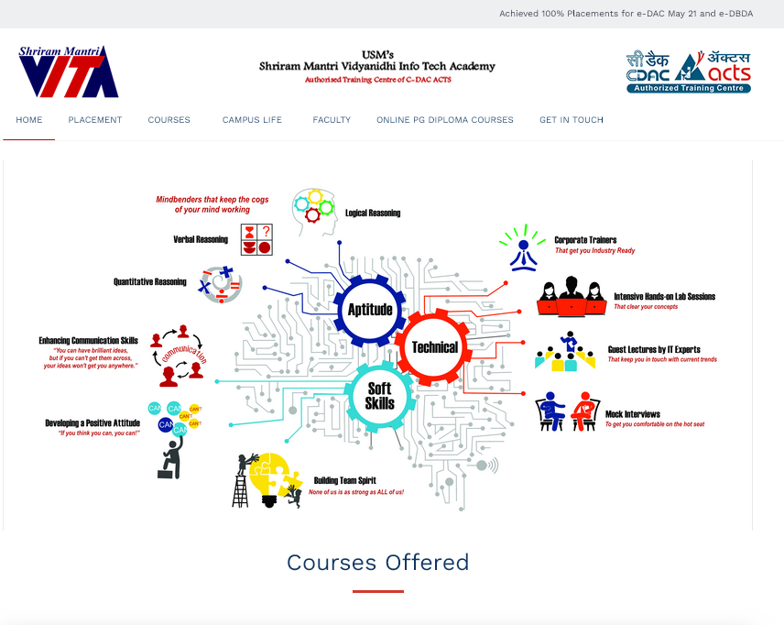

On top of the page there will be crawling text area in which various announcements will be displayed. All text items should come from database. Each Item will have validity for displaying it. Only valid items will be displayed.

The “courses” button will have drop down menu which will show all courses conducted by VITA. All valid/active courses will be loaded from the database. On click the user will be navigated to that course detail page.

“Campus Life” Page will display various images (photos) with captions.

“Faculty” page will display the details of each faculty member along with his/her photo (if available). Entire content of this page (including images) will be database driven. Only “active” faculty should be displayed.

“Placement” will have options thru dropdown menu. Currently options are “Batchwise Placement” and “Our recruiters”. On click the user will be navigated to respective page as shown below.

Batchwise Placement Page

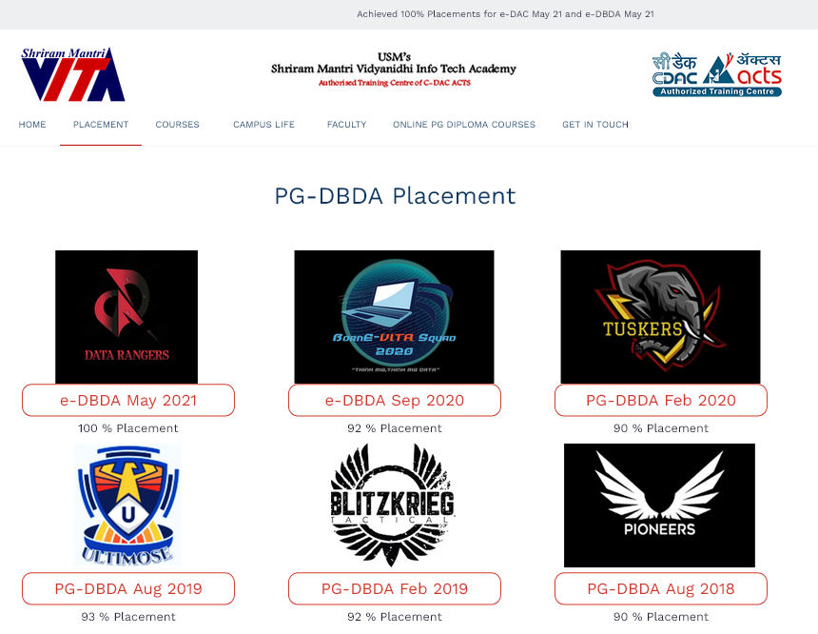

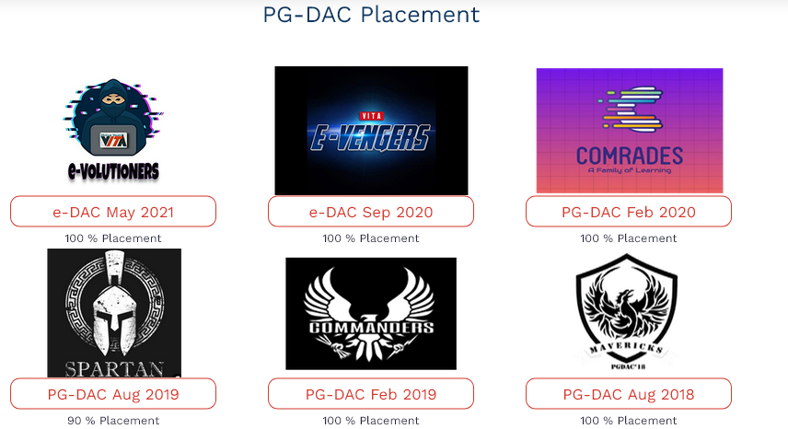

On click, the Placement detail page will be displayed as shown below. This page will display student photo, name and name of the recruiter.

Placement Detail Page

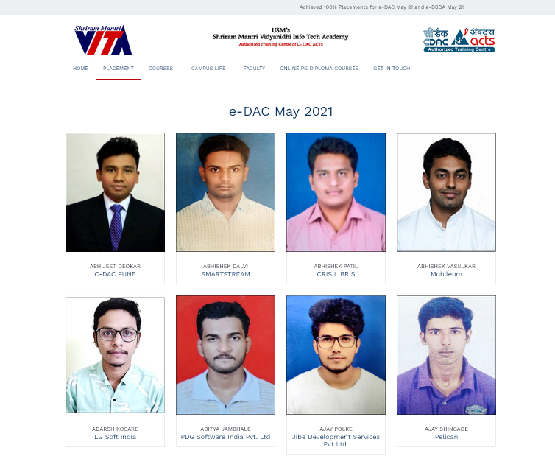

Entire content of this page will be database driven.

Our Recruiters Page

This page will display all major recruiters. The logo of each company will be displayed. Only active companies will be displayed.

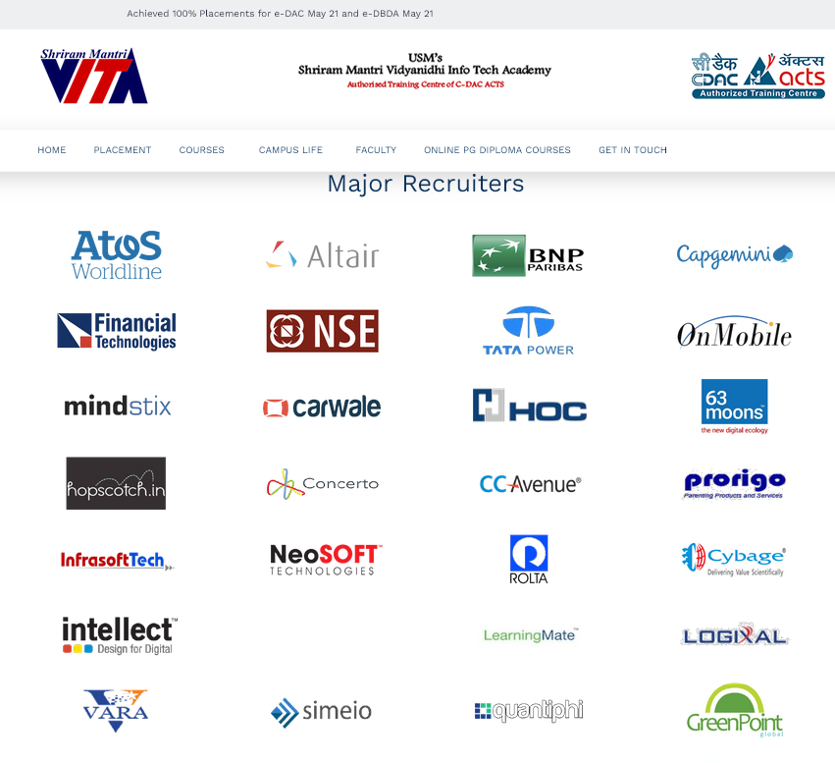

Get in Touch

This is a static page with following data. The static text will appear under paragraphs “Our Origin” and “Reach us at”. The page will also display a location of institute in Google map.
It will also have a facility thru which user can send a message to SMVITA. This should capture name of the user, email, and the message. Message box will allow user to type a text upto 500 characters. On click “Send Message” button the data will be saved in database and appropriate mail will be sent to predefined mail-id.

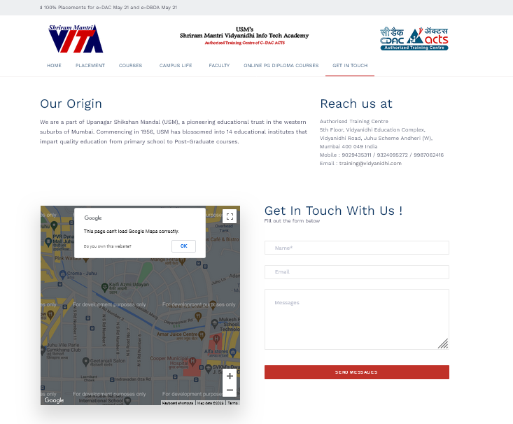

Admin Panel:

Access to this module will be restricted to the general public. Only authorized staff members will have access to this module.

The Admin panel will consist of following functionalities.
- Inquiry
- Follow up
- Student Registration:
- Table Maintenance

The default landing page for any authorised staff member will be “Follow-up” page. In other word, after successful log-in the staff member will be diverted to Follow-up page.

Add Enquiry Page

This page should allow staff to add all enquiry details. Every enquiry whether it comes in any form (Telephonic, Walk-in, eMail, Online, Fax etc.) shall be entered thru this module. Each registration (admission) shall be done with reference to the enquiry. There may be the possibility that student/parent will enquire for a course A but may register for the course B. The registration for course B shall be with respect to the enquiry made by the said student for course A and by this way the enquiry will be “closed” automatically thru “Registration/Admission” module.

Follow-up Page

On this page, a list of all follow-ups due on the date (today) for the logged-in staff member along with all pending follow-ups (if any) will be dispalyed. A staff member will be able to see all follow-ups by clicking “View All” link/button. This will show follow-ups due on date and any pending follow-ups of prior days for all staff members. The list will show the enquiry details such as Enquiry id, Name, Phone No., the course for which enquiry was done, Follow-up date, etc. Each row will have “Call” button and on-click “Call” button the system will display the respective enquiry (this page is nothing but the Add Enquiry page with pre-filled data. However, this page will also display/collects the further information such as remarks, special instructions, reason for closure etc). The staff will update the necessary data and set the next follow-up date. (By default, next follow-up date will be set after 3 days. However, staff will be allowed to change the same.). If needed, staff will “Close” the enquiry with the reason for closure.



Welcome <Staff Name>
View All

Enq.Id | Enquirer Name | Student Name | Phone | Course | Follow-up date | Staff Name | Action
1 | XXXXXX | AAAAAA | 9812345678 | PG DAC | 12-Oct-22 | Ruchita
2 | YYYYYY | BBBBBBBBB | 9812345679 | PG DBDA | 14-Oct-22 | Ruchita
3 | ZZZZZZ | CCCCCCCC | 9812345680 | MSCIT | 14-Oct-22 | Ruchita
4 | PPPPPPPPPPP | QQQQQQQ | 1234567890 | JAVA | 13-Oct-22 | Snehal
Begin Next Previous End

FOOTER AREA

Student Registration

This module will allow user to register student for a course and print a receipt for the fees paid.

First, the staff member will search for an enquiry based on Phone No, and/or Name. The search result may show multiple results in case of search made on name. User will select the appropriate enquiry and click on register button. This action will open an enrolment form as shown in “Annexure 1”. Some of the information will be pre-filled. User will enter the information, upload the photo (if available) and print the form. This module will also allow user to print the receipt.

Table Maintenance

This module will allow user to create, update, and delete the content of all master tables that are needed to populate the site. Please note transaction tables will never be updated thru Admin panel’s Table maintenance option. Some of the master tables could be “Placement”, “Recruiter”, “Course”, etc. This option will have dropdown menu which will list out all master tables. On click the user will be navigated to the respective table page thru which user will able to add/update/delete the row (record) in that table. This page (for any table) will display the list of all records in tabular format (grid) with the facility of searching any particular record. Each row will have “Update”/”Delete” option thru which user will perform necessary action. “Add” button should be provided on top of the grid.

Excel data upload
The system should provide user to upload product in bulk thru’ Excel wherever appropriate. The tables for which data upload is required will be decided later. Excel format to enter the data should be provided.

General Information

- Team leaders need to submit report every week
- All milestone should to be submitted as per schedule.
- Any change (if needed) in system will require prior approval.
- Assumptions made should be informed and should be approved.

Point Of Contact

All queries may be sent to Jayant Ponkshe thru mail jayant.Ponkshe@gmail.com or may be discuss in person.

Annexure 1:
ENROLLMENT FORM

USM’S VIDYANIDHI INFO TECH ACADEMY

5th Floor, Vidyanidhi Educational Complex, Vidyanidhi Marg,
JVPD Scheme, Juhu, Mumbai – 400 049
Tel: 22-26255629 /2670 54 98 E-mail: training.vita@gmail.com

Name: ___________________________________________________

Date of Birth: ___________________ Male/Female: ____________

Res Address: ______________________________

Office Address: _________________________________________

Phone (R) ____________ (O) ___________ Mobile__________

E-mail ID: ___________________________________

Educational Qualification: ___________________________________

Course enrolled for: __________________ Starting from: ____________ Time: _____________

I hereby apply for admission to the abovementioned course. Paying by cash/cheque/Demand Draft for Rs. _________________;the cheque/DD no. __________ of______________________ bank dated _____________. I agree to abide by the rules & regulations of the Institute.

Date: __________ Signature of Applicant: ______________

********** This page is kept blank intentionally **********

